Conquip water cube stabiliser being used
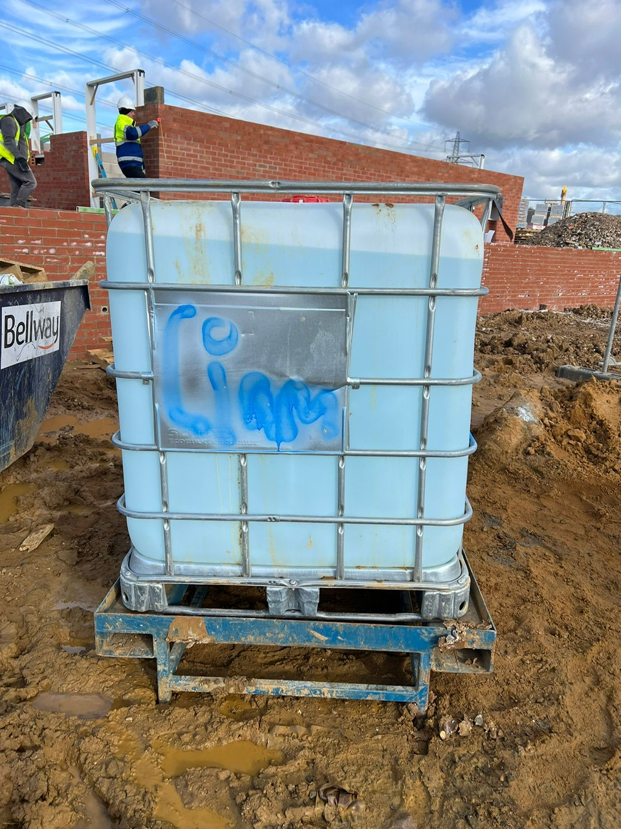
Site stack being utilised for drainage fittings
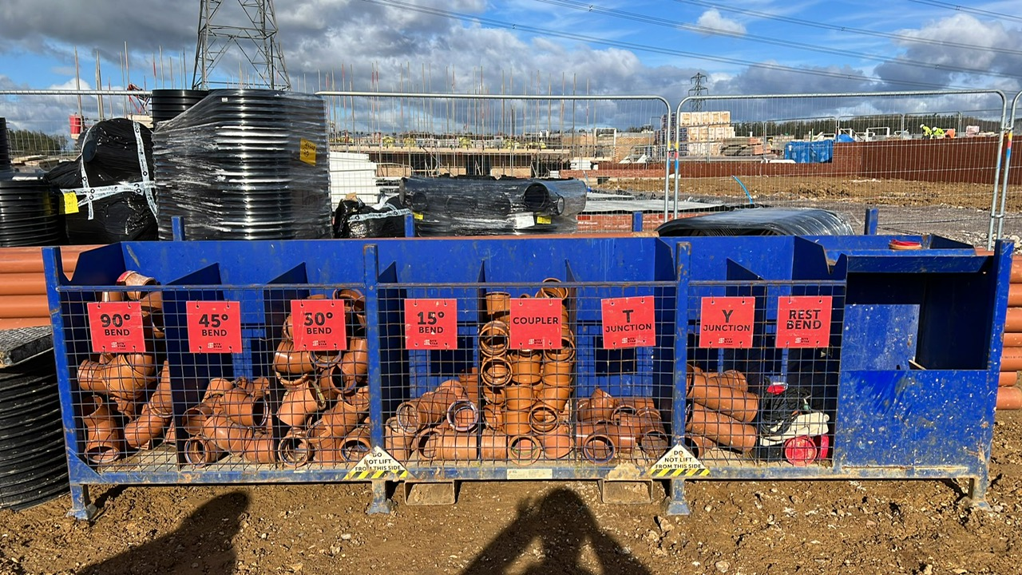
Petrol saw stored on drip tray ready for re fuelling.
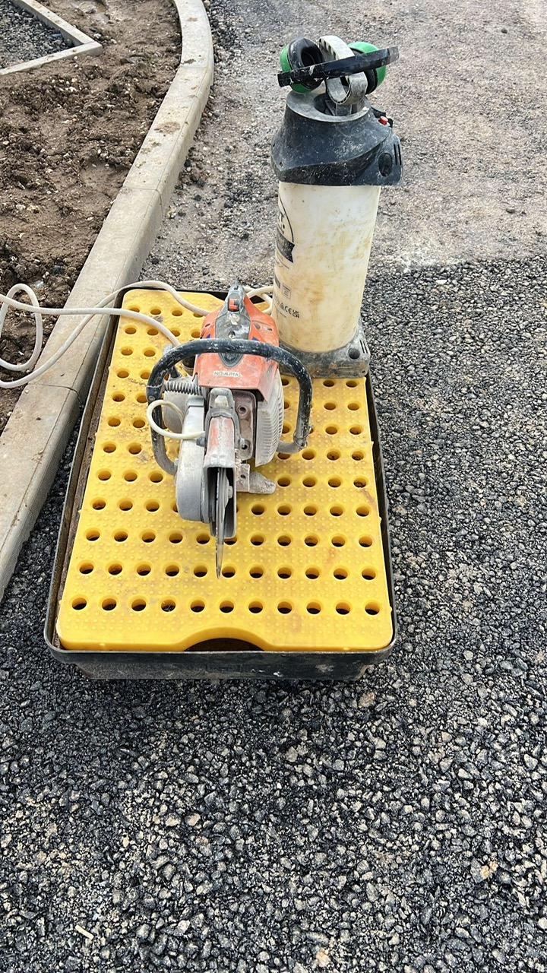
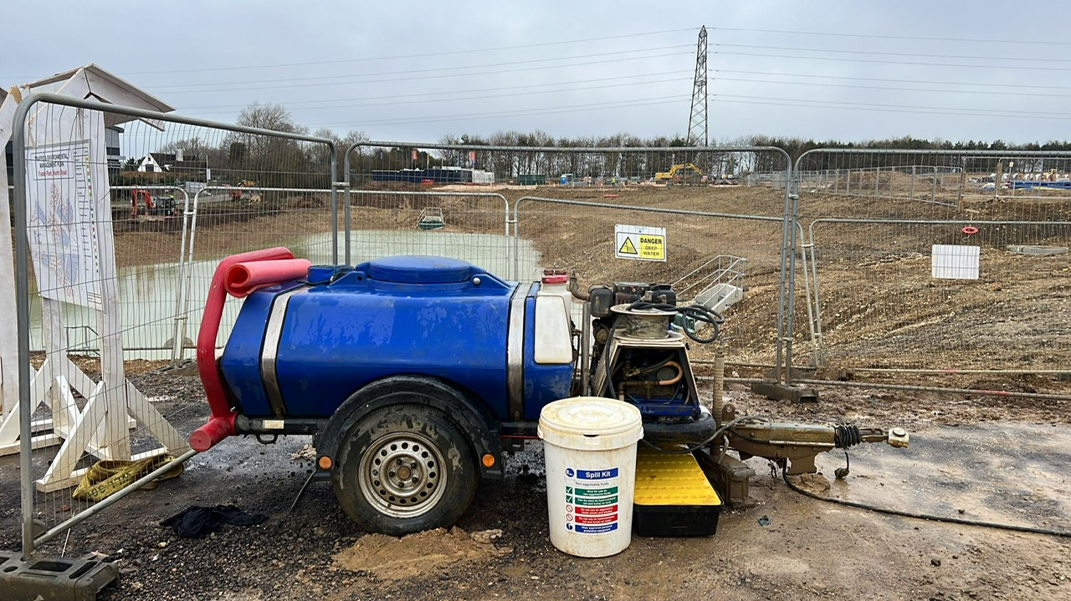
Jetwash with tow lock fitted, drip tray and spill kit present.

